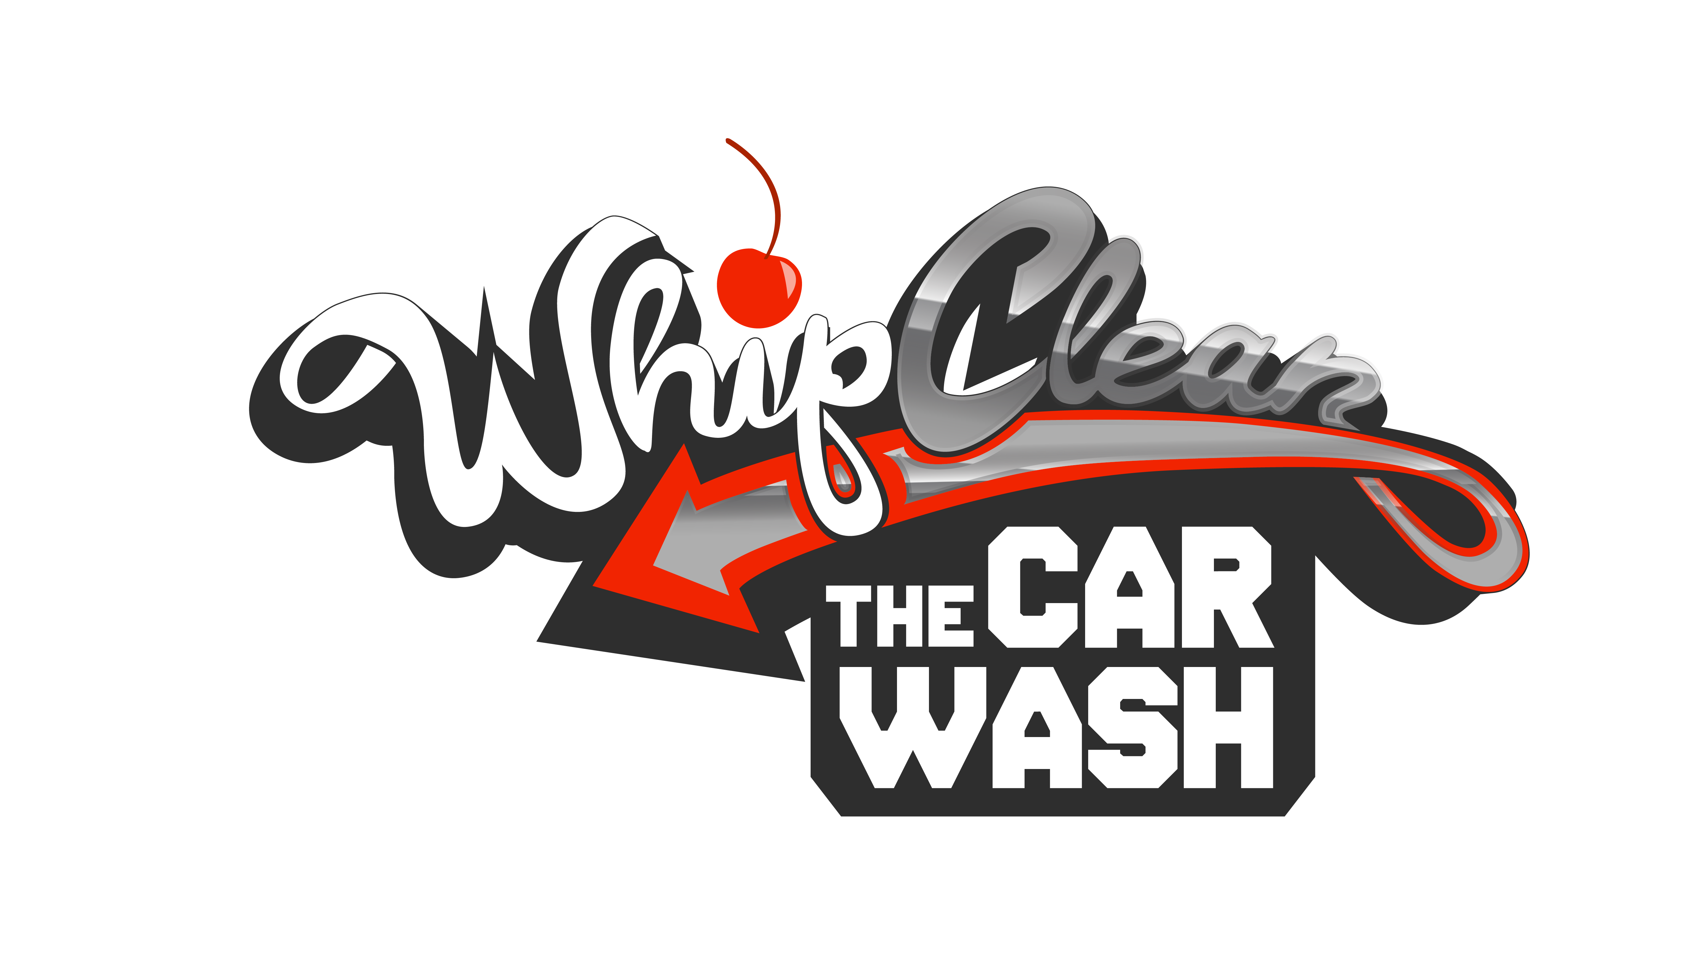

Employment Application

1956 Crain Hwy, Bowie, MD 20716 | P: 301.390.1000
careers@whipclean.com | www.whipclean.com

Applicant Information
First Name: ______________________________________________________________________________________
Last Name: ______________________________________________________________________________________
Phone Number: __________________________________________________________________________________
E-mail: _________________________________________________________________________________________
Address: ________________________________________________________________________________________
City/State/Zip Code: ______________________________________________________________________________

Which position are you applying for?
Cashier
Detailer
Service Advisor
Team Member

Availability
How many hours do you prefer to work per week?: ______________________________________________________
What hours are you available to work each day of the week?:
Monday: ______________________________________ Friday: _________________________________________
Tuesday: ______________________________________ Saturday: _______________________________________
Wednesday: ___________________________________ Sunday: ________________________________________
Thursday: _____________________________________

Recent Employment
Company Name: _________________________________________________________________________________
Company’s Address: ______________________________________________________________________________
City/State/Zip Code: ______________________________________________________________________________
Supervisor: ______________________________________________________________________________________
Supervisor’s Phone Number: ________________________________________________________________________
Date Employment Started: __________________________________________________________________________
Date Employment Ended: __________________________________________________________________________
Job Title: _______________________________________________________________________________________
Responsibilites: __________________________________________________________________________________
Reason For Leaving: ______________________________________________________________________________
May we contact your supervisor for a reference? Yes No

Personal References
(References may not be related to you or currently employed by Whip Clean - The Car Wash)
Name: ________________________________________ Phone Number: __________________________________
Relationship: ____________________________________________________________________________________
Name: ________________________________________ Phone Number: __________________________________
Relationship: ____________________________________________________________________________________

Additional Information
Do you have a current valid Driver’s License?: Yes No
Issuing State of Driver’s License: ____________________________________________________________________
Driver’s License Number: __________________________________________________________________________
Driver’s License Expiration Date: ____________________________________________________________________
Have you ever been convicted of a felony?: Yes No
If yes, please explain: ______________________________________________________________________________
________________________________________________________________________________________________
Have you ever been convicted of a D.U.I or D.W.I?: Yes No
If yes, date: ______________________________________________________________________________________

Please list any additional skills that are appropriate for the position that you are applying for that you think would be helpful to us in considering you for employment:
________________________________________________________________________________________________________________________________________________________________________________________________

Referral Source
How did you find out about Whip Clean - The Car Wash?:
________________________________________________________________________________________________

APPLICANT’S CERTIFICATION AND AGREEMENT
- I authorize investigation of all information contained in this application, and I authorize the persons, schools, employers, organizations, and entities named in this application to provide Whip Clean – The Car Wash (the “Company”) with all information that may be required to arrive at an employment decision. I hereby release from liability Whip Clean – The Car Wash and its representatives for seeking, gathering, and using such information and all other persons, schools, corporations, or organizations for furnishing such information. I certify that the information I have provided on this application is complete and accurate to the best of my knowledge. I understand that a false answer, misrepresentation, or omission of any material fact will constitute grounds for disqualifying me for employment or dismissal if I am employed.
- I understand that I may be required to pass a pre-employment drug test. I further acknowledge that certain positions with the Company may also require a confirmation that I am licensed to drive a motor vehicle, and that my credit, civil and criminal records may be checked including a verification of my address. I consent freely and voluntarily to participate in the required drug test and background checks, and consent to the release of the results to the Company. I hereby release and hold harmless the Company from any liability whatsoever arising from the drug test and/or background checks and decisions concerning employment based upon the results of these tests and checks.
- I understand and accept that if I am hired, my employment with Whip Clean – The Car Wash is at-will. I have the right to resign at any time with or without cause, just as the Company may terminate my employment at any time with or without cause or notice, subject to applicable laws. I understand that nothing in the handbook or in any oral or written statement alters the at-will relationship, except by written agreement signed by the employee and the President of the Company.
- If hired, I agree to conform to rules, regulations, and policies that Whip Clean – The Car Wash may periodically issue, withdraw or modify. If hired, I understand that I will be required to keep my hair color within the range of "natural" colors (no blue, green, or other non-natural hair colors are allowed) and that facial piercings are not appropriate. I also understand that in order to comply with the Company’s policy any visible tattoos will need to be covered appropriately during the workday, if hired. I agree to follow the Company’s grooming guidelines and to be dressed appropriately per the standards of the Company at all times in the workplace, if I am hired.
- This application is only effective for thirty days. At the conclusion of that time, if I have not heard from Whip Clean – The Car Wash and still wish to be considered for employment, I understand that it will be necessary to fill out a new application form.
- Whip Clean – The Car Wash is an equal opportunity employer and does not discriminate against otherwise qualified applicants on the basis of race, color, creed, religion, ancestry, age, sex, marital status, national origin, disability or handicap, veteran status, or any other category protected by applicable federal, state, or local laws.
- I acknowledge that I have read and understand all of the foregoing statements.

Applicant’s Name: ________________________________________________________________________________
Applicant’s Signature: ________________________________________________________ Date: _______________

